

Entertainer Data Analytics

KRITIKA SHARMA | DATA SCIENCE | MARCH 11, 2024

# **PROBLEM STATEMENT**

Normal life can be stressful, and people need to relax. Being entertained by others is a wonderful way to take some time out of life. It can reduce stress and make life's issues easier to face. The media and entertainment industry consists of film, television, radio and print. These segments include movies, TV shows, radio shows, news, music, newspapers, magazines, and books. The entertainment industry is a group of sub-industries devoted to entertainment. The entertainment industry is used to describe the mass media companies that control the distribution and manufacture of mass media entertainment.

# **INTRODUCTION**

# Background information about the dataset and the purpose of the analysis.

# Objectives of the analysis, such as identifying trends, correlations, and insights into the entertainment industry.

# **DATA OVERVIEW**

* Description of the Entertainer dataset, including the columns and their meanings.
* Data preprocessing steps, such as handling missing values, data cleaning, and data transformation**.**

# **Exploratory Data Analysis (EDA)**

# Summary statistics of key variables like Age, Year of Breakthrough, etc.

# Visualization of distributions (histograms, box plots) and relationships (scatter plots, correlation matrices) between variables.

# **Key Insights and Findings**

# **Breakthrough Analysis**

# Identification of significant breakthrough years and their impact on the entertainer's career.

# Visualization of Breakthrough Age distribution and its relationship with the Year of Breakthrough.

# **Gender Analysis**

# Analysis of gender distribution among entertainers and its impact on career milestones.

# Comparison of Breakthrough Ages between genders.

# **Career Span Analysis**

# Analysis of the duration of careers for different types of entertainers.

# Visualization of career spans using survival analysis techniques.

# **Award Nomination Analysis**

# Identification of key factors influencing award nominations.

# Visualization of Award Nomination trends over the years.

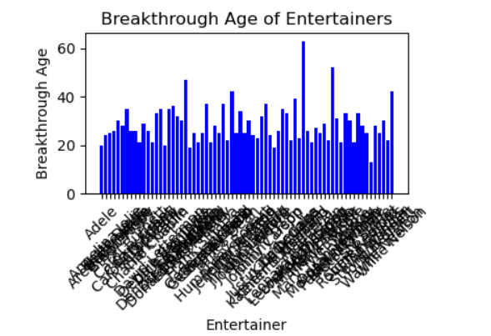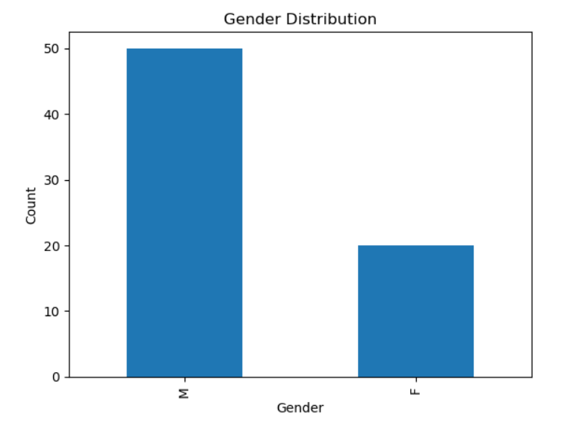

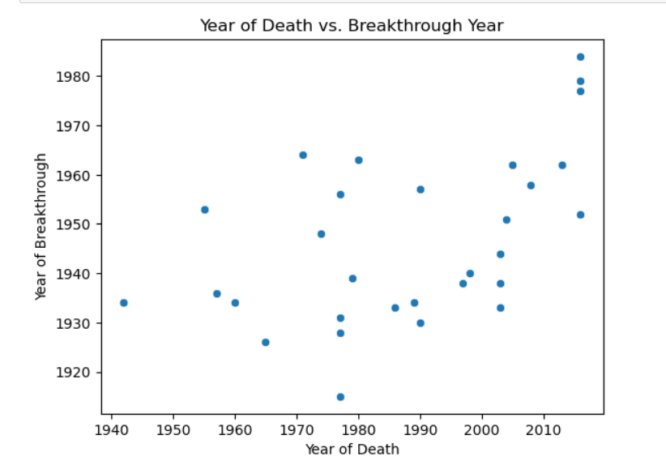

# **Advanced Analytics**

# **Predictive modeling:**

# Building predictive models (e.g., regression, classification) to predict career longevity or future breakthroughs.

# Evaluation of model performance and key predictors.

# **Clustering Analysis**

# Clustering entertainers based on career trajectories or attributes.

# Identification of distinct groups and their characteristics.

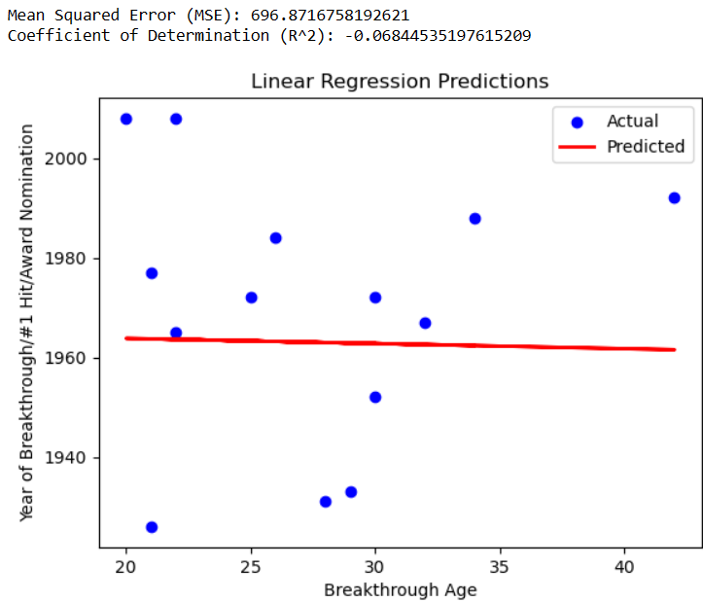

# **Recommendations**

# Key insights derived from the analysis, such as factors influencing career success, gender disparities, etc.

# Recommendations for stakeholders in the entertainment industry based on analysis findings.

# **Conclusion**

# Impact of the analysis on understanding the dynamics of the entertainment industry..